Docker File
mkdir dir2
ls
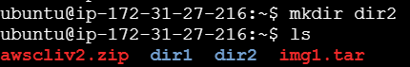
vi Docker
FROM ubuntu:22.04

# Update package lists and install Nginx
RUN apt update && apt install nginx -y

# Expose port 80
EXPOSE 80

# Set working directory
WORKDIR /usr/share/nginx/html

# Create index.html and write content to it
RUN echo "Welcome To AWS" > index.html

# Start Nginx in the foreground
CMD ["nginx", "-g", "daemon off;"]

Ls
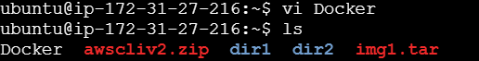
Vi Dockerfile
Ls
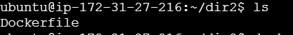
docker build .
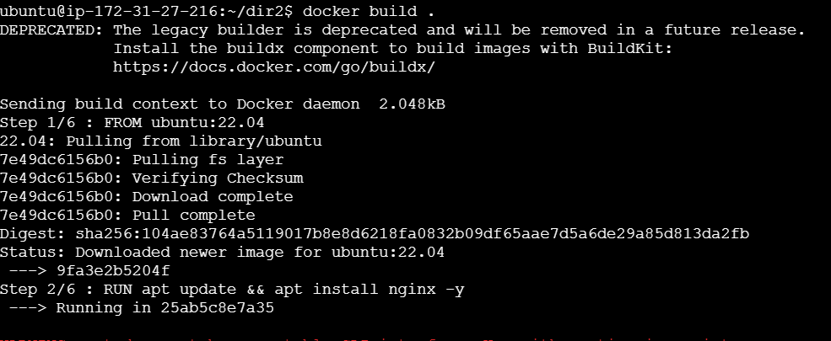
Docker images
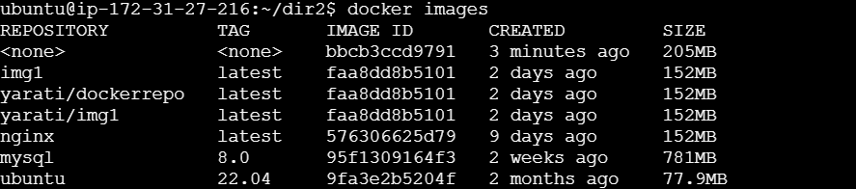
docker run -d -p 80:80 --name container1 bbcb3ccd9791

docker ps -a
docker exec -it container1 bash
ls
cat index.html
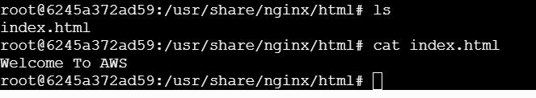
Exit
Copy public IP and host
